
Exploring the Virtual Rainforest Name: ________________________
Scavenger Hunt – Find Your Answers in the Virtual Rainforest

What is a large predator
in the Central American rainforest ________________________________________________

What is the name of the yellow snake? ________________________________________________

Name TWO kinds of ants that live in ________________________________________________
the rainforests of Central America ________________________________________________

What are TWO kinds of insects that ________________________________________________
are not ants living in the rainforest. ________________________________________________

What are two kinds of monkeys? ________________________________________________
________________________________________________

What other mammal species
likes to live in the trees? ________________________________________________

What is the smallest bird? ________________________________________________

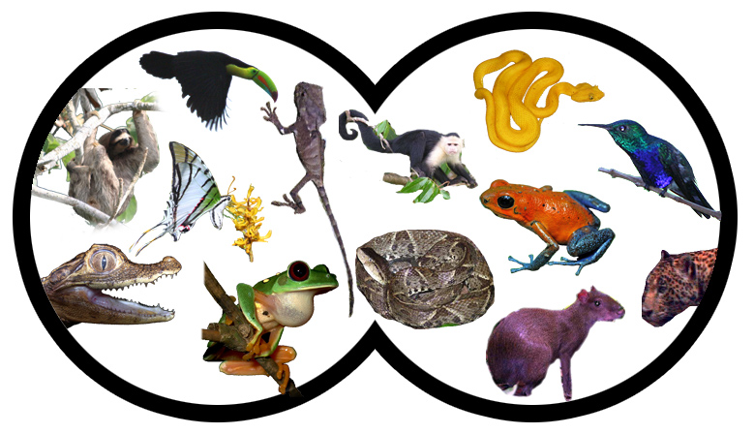 | In your binoculars you can see lots of animals. Circle all the animals that eat other animals.

